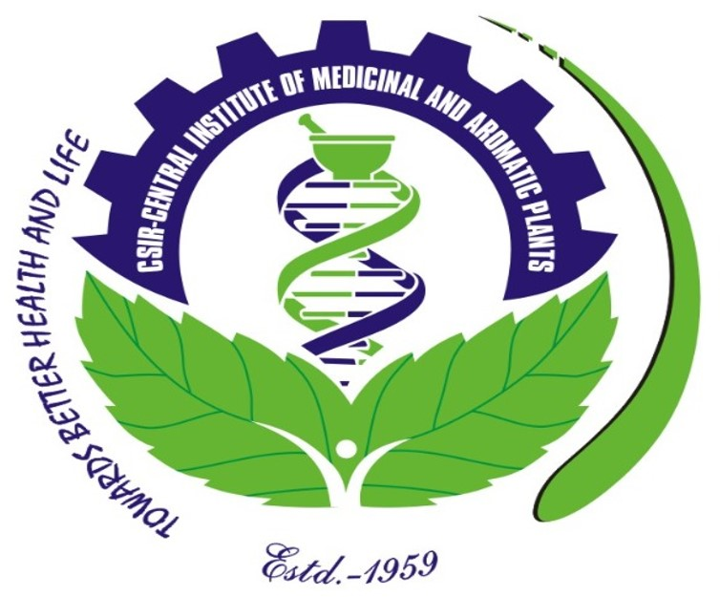 | CSIR-CENTRAL INSTITUTE OF MEDICINAL AND AROMATIC PLANTS  RESEARCH CENTRE, BENGALURU-560065  Training Programme on ‘Improved Production Technologies of  Aromatic and Medicinal Plants & Aromatic Oils’  (Under Aroma Mission Phase III – HCP 0007) | 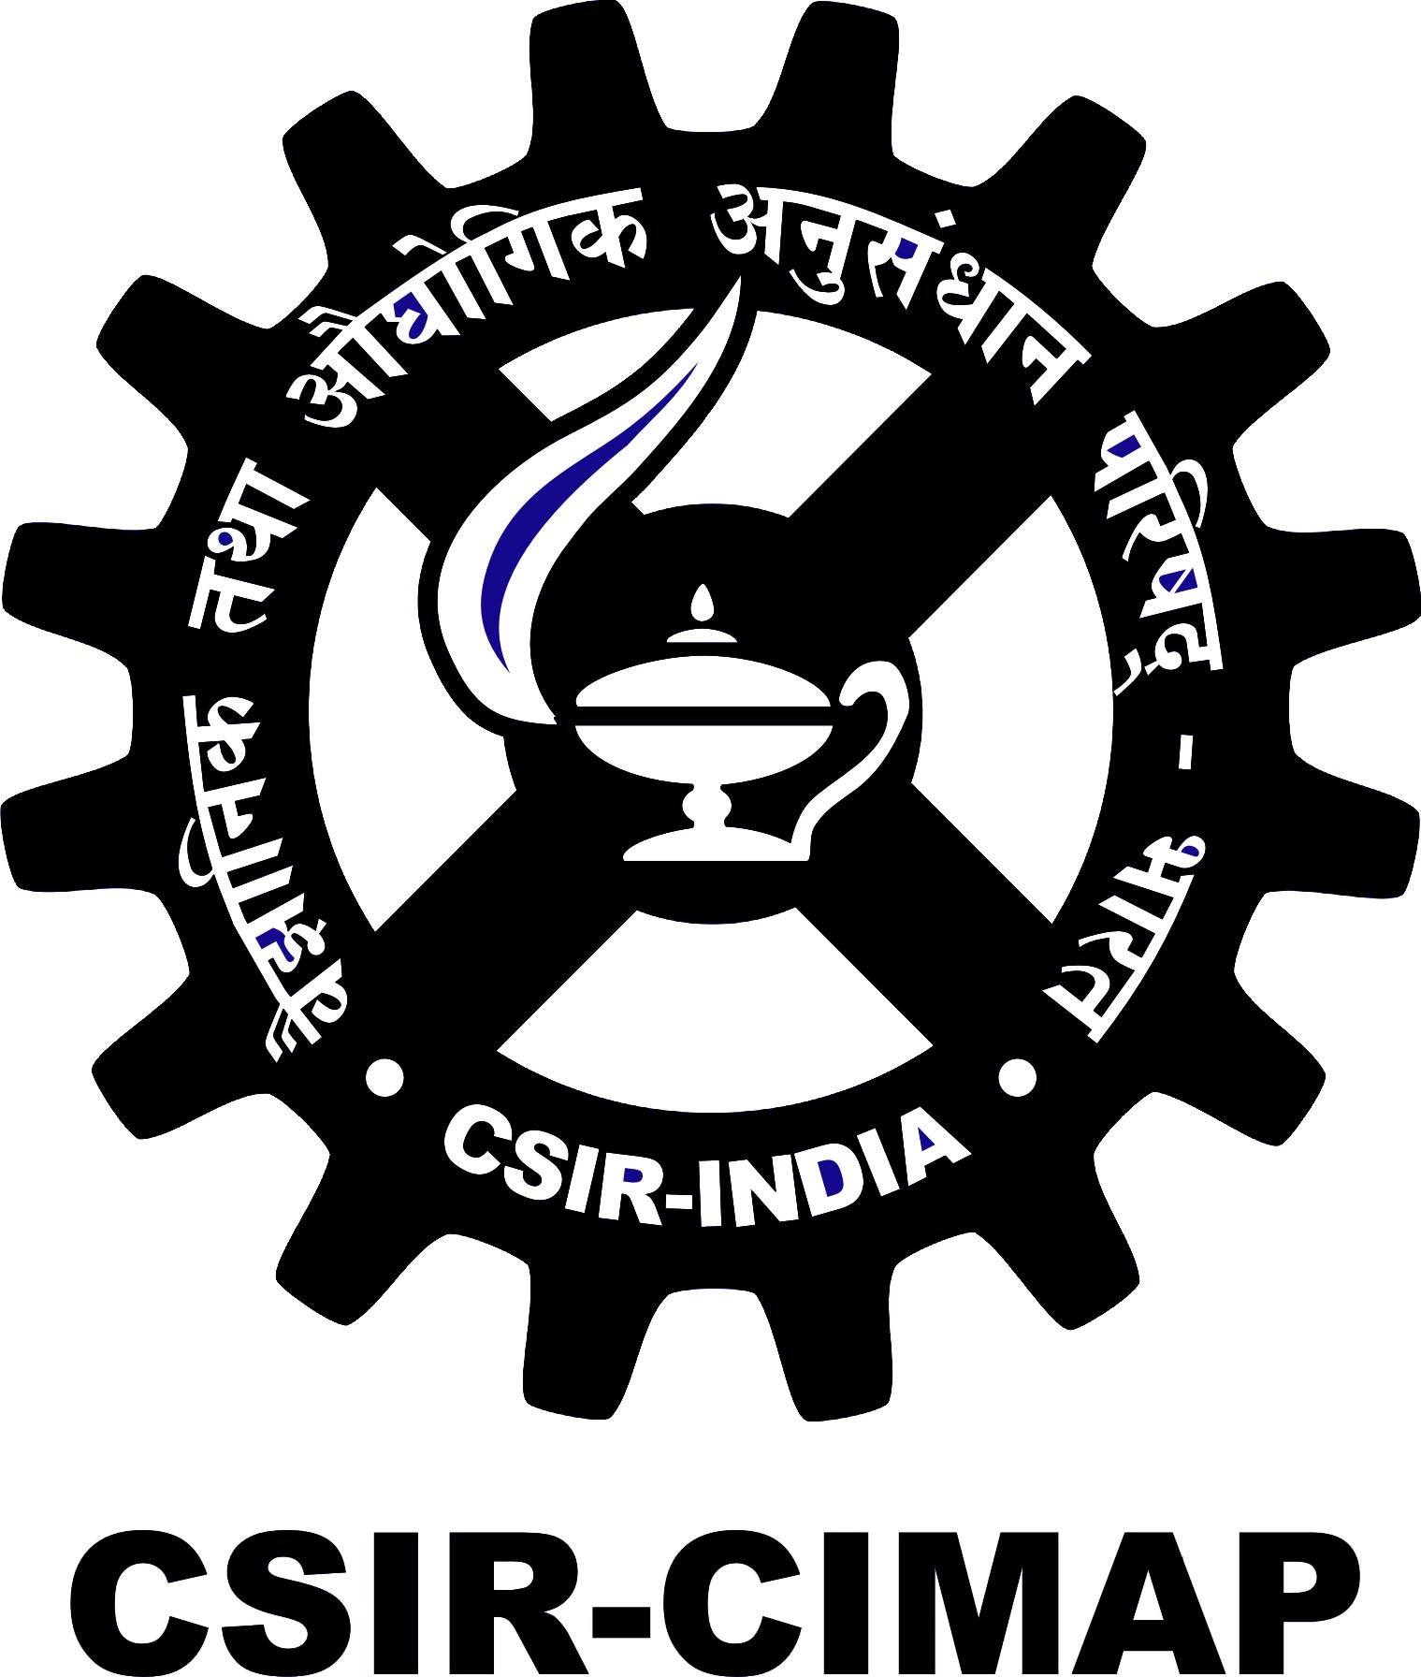
Venue : Gandhigram Trust (GGMT), Gandhigram, Dindigul District, Tamil Nadu

Date : 11 – 13 September, 2023

REGISTRATION FORM

PHOTO
- Name :

- Father’s Name :

- Date of Birth :

- Educational Qualification :

- Category : Gen/OBC/SC/ST

- Present Address :

- Phone/Mobile No. :

- E-mail :

- Aadhar No. :

- Name of organisation/ :
Individual & Address

- Description of land for :
Cultivation (Acre/ha)

- Annual Income :

- Other information, if any :
- Crops cultivated at present, if any :

- Details of online payment : Transaction No.
Date :

Place:
Date: SIGNATURE

Note: Please attach a valid Photo ID

